Q1 c): Merge Sort (Inversion Count)
#include <iostream>
#include <vector>
using namespace std;

// Merging two sorted arrays and counting the inversions
long long mergeAndCount(vector<double>& A, int left, int mid, int right) {
int n1 = mid - left + 1;
int n2 = right - mid;

// Create temporary arrays
vector<double> L(n1), R(n2);

// Copy data to temp arrays L[] and R[]
for (int i = 0; i < n1; i++)
L[i] = A[left + i];
for (int i = 0; i < n2; i++)
R[i] = A[mid + 1 + i];

// Merge the temp arrays back into A[left..right]
int i = 0, j = 0, k = left;
long long inversions = 0;

while (i < n1 && j < n2) {
if (L[i] <= R[j]) {
A[k++] = L[i++];
} else {
A[k++] = R[j++];
// Count inversions, because all remaining elements in L are greater than R[j]
inversions += (n1 - i);
}
}

// Copy the remaining elements of L[], if there are any
while (i < n1) {
A[k++] = L[i++];
}

// Copy the remaining elements of R[], if there are any
while (j < n2) {
A[k++] = R[j++];
}

return inversions;
}

// Divide and conquer method to sort the array and count inversions
long long mergeSortAndCount(vector<double>& A, int left, int right) {
long long inversions = 0;
if (left < right) {
int mid = left + (right - left) / 2;

// Count inversions in the left half and right half
inversions += mergeSortAndCount(A, left, mid);
inversions += mergeSortAndCount(A, mid + 1, right);

// Count the inversions during the merge process
inversions += mergeAndCount(A, left, mid, right);
}
return inversions;
}

int main() {
int n;
cout << "Enter the size of the array (at least 10): ";
cin >> n;

if (n < 10) {
cout << "Please enter a size of at least 10." << endl;
return 1;
}

vector<double> A(n);
cout << "Enter " << n << " real numbers: ";
for (int i = 0; i < n; i++) {
cin >> A[i];
}

long long inversions = mergeSortAndCount(A, 0, n - 1);

cout << "The number of inversions is: " << inversions << endl;
cout << "The sorted array is: ";
for (double num : A) {
cout << num << " ";
}
cout << endl;

return 0;
}

OUTPUT:
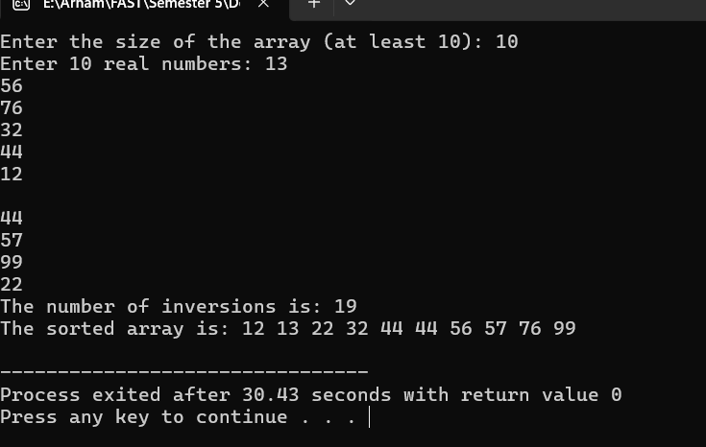
Q1 D): Quick-Sort Algorithm
#include <iostream>
#include <vector>
using namespace std;

int partition(vector<double>& A, int low, int high) {
double pivot = A[high]; // choosing the last element as the pivot
int i = low - 1; // Index of the smaller element

for (int j = low; j < high; j++) {
if (A[j] <= pivot) {
i++;
// Swap A[i] and A[j]
swap(A[i], A[j]);
}
}

swap(A[i + 1], A[high]);
return i + 1;
}

void quicksort(vector<double>& A, int low, int high) {
if (low < high) {

int pivotIndex = partition(A, low, high);

quicksort(A, low, pivotIndex - 1); // Before pivot
quicksort(A, pivotIndex + 1, high); // After pivot
}
}

int main() {
int n;
cout << "Enter the size of the array (at least 10): ";
cin >> n;

if (n < 10) {
cout << "Please enter a size of at least 10." << endl;
return 1;
}

vector<double> A(n);
cout << "Enter " << n << " real numbers: ";
for (int i = 0; i < n; i++) {
cin >> A[i];
}

quicksort(A, 0, n - 1);

cout << "The sorted array is: ";
for (double num : A) {
cout << num << " ";
}
cout << endl;

return 0;
}
OUTPUT:
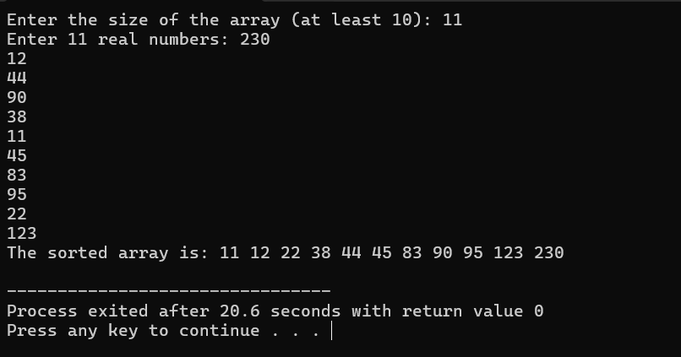
i): Worst Case Time complexity of Quick-Sort Algorithm is O(n^2). While Best Case Time complexity is O(n logn).

Q1 e): Closest pair problem (One- Dimensional Version)
#include <iostream>
#include <vector>
#include <algorithm>
#include <cmath>
#include <limits>

using namespace std;

double minDistance(double d1, double d2) {
return (d1 < d2) ? d1 : d2;
}

// Brute force approach to find the closest pair in a small set
double bruteForceClosestPair(const vector<double>& A, int left, int right) {
double minDist = numeric_limits<double>::max();
for (int i = left; i < right; i++) {
for (int j = i + 1; j <= right; j++) {
minDist = min(minDist, abs(A[i] - A[j]));
}
}
return minDist;
}

double closestPairDivideAndConquer(const vector<double>& A, int left, int right) {
// Base case: if there are 2 or 3 elements, use brute force
if (right - left <= 2) {
return bruteForceClosestPair(A, left, right);
}

int mid = left + (right - left) / 2;

double dLeft = closestPairDivideAndConquer(A, left, mid);
double dRight = closestPairDivideAndConquer(A, mid + 1, right);

// Find the minimum distance from the left and right sides
double d = minDistance(dLeft, dRight);

// Combine step: Check the closest pair that crosses the middle
double crossMinDist = abs(A[mid] - A[mid + 1]);

return minDistance(d, crossMinDist);
}

int main() {
int n;
cout << "Enter the size of the array (at least 10): ";
cin >> n;

if (n < 10) {
cout << "The size of the array must be at least 10." << endl;
return 1;
}

vector<double> A(n);
cout << "Enter " << n << " real numbers: ";
for (int i = 0; i < n; i++) {
cin >> A[i];
}

sort(A.begin(), A.end());

double closestDist = closestPairDivideAndConquer(A, 0, n - 1);

cout << "The closest distance between two numbers is: " << closestDist << endl;

return 0;
}
OUTPUT:
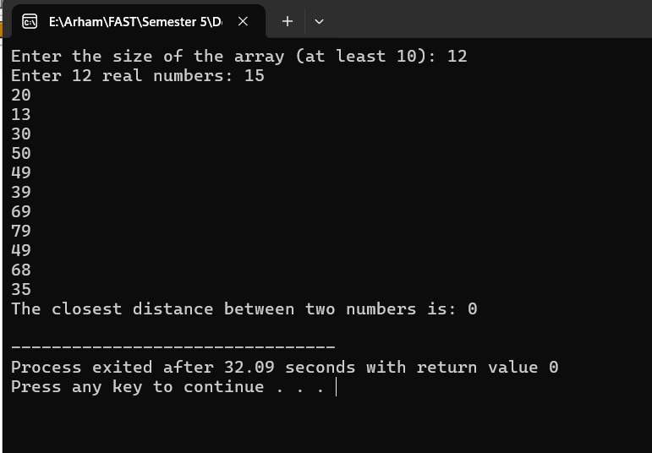
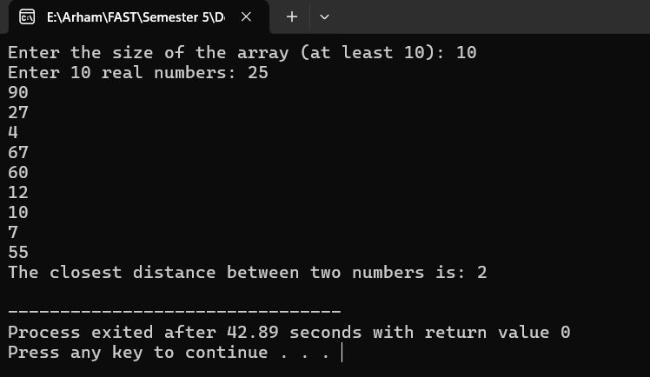

i): Efficiency Class
The efficiency of this algorithm is O(n logn) similar to that of merge sort algorithm. This is due to recursive division of array and O(n) times in the merging part.
ii): Is this Algo Good enough?
This divide-and-conquer algorithm is not necessarily optimal compared to simple sorting-based approach.
In sorting-based approach, you can simply sort the array in O(nlogn) times and then search through the array to find the smallest distance between consecutive elements in O(n) times. This approach is conceptually simple to implement.

